**Deploy a Python Flask App using Docker**

**1)create app.py**

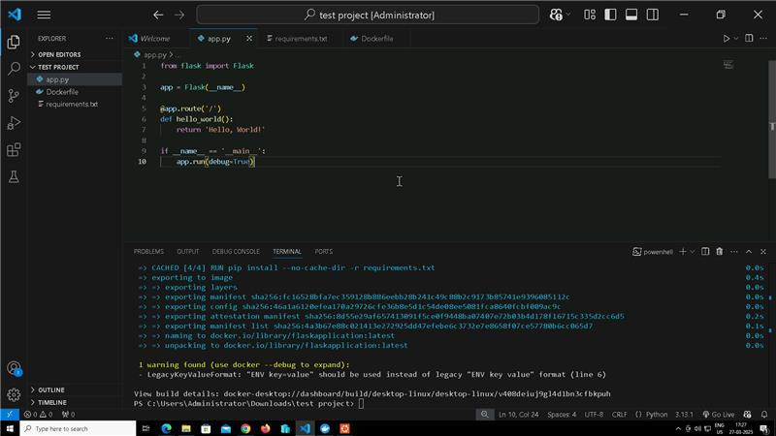

**2)create the docker file and requirements.txt file**

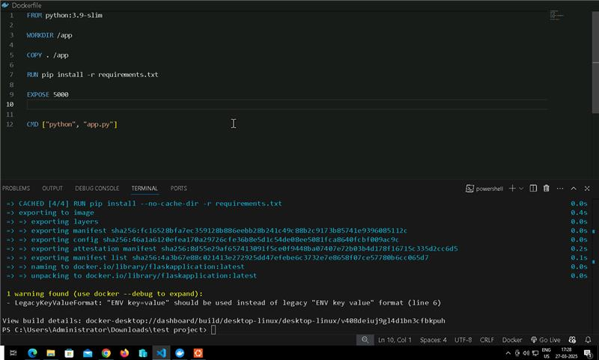

**3)Build the docker image by using docker build command**

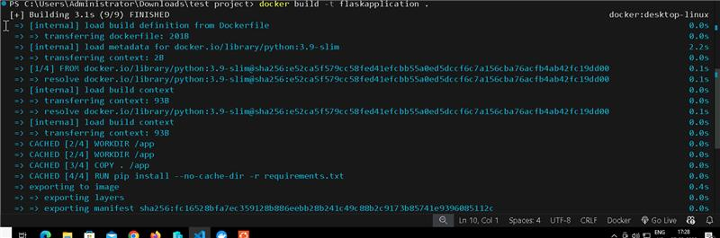

**4)Now run it using docker run**

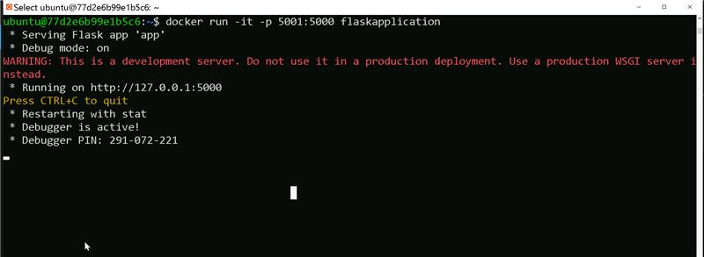

**5)So in the below output we can see that it is running on port 5001**

